Tuesday 21/7/2026
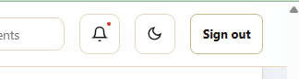
- THIS NOTIFICATION BUTTON IS NOT WORKING, IT OUGHT TO SHOW A FEW NOTIFICAITONS AND SHOW THE MORE BUTTON THAT TAKES ON TO THE NOTIFICAITON PAGE OR SECTION
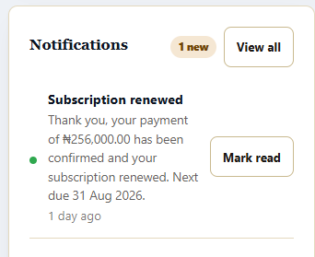
- CLICKING ON THE MARK READ BUTTON DOES NOT NEED TO RELOAD THE PAGE, ALSO IT SHOULD BE MARK AS READ AND NOT MARK READ

- Parent Portal DOES NOT HAVE THE VIEW ALL PARENT LIST AS WE HAVE IT UNDER THE STAFF PORTAL

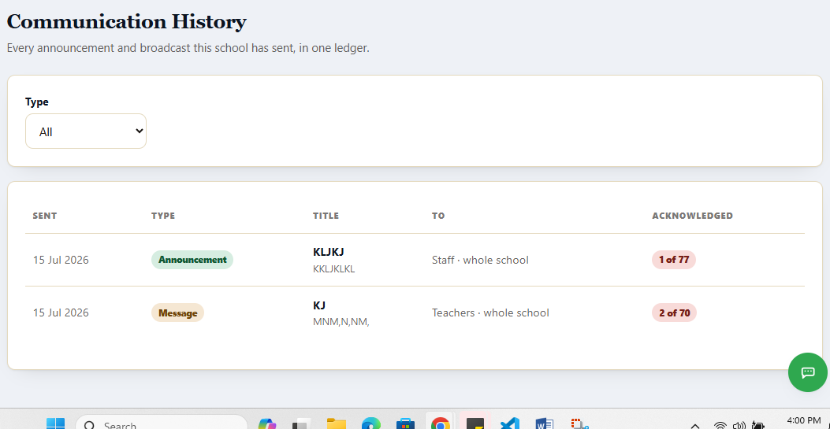
- ONE SHOULD BE ABLE TO SEE LIST OF THOSE WHO ACKNOWLEDGE EACH COMMUNICATION SO AS TO ALSO NUDGE THOSE WHO ARE YET TO DO SO

- The countdown time when idle got to 0 and was stuck for a while instead of it to logout immediately it got to 0, it only log out when on go back to the tab or window

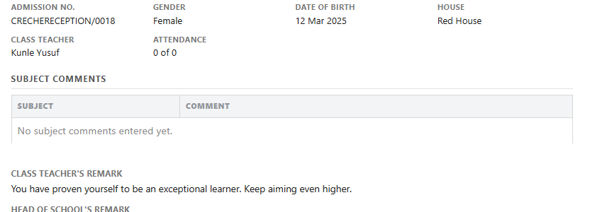
- Let’s populate report for classes with the Narrative Evaluation settings

- This kind of class is not seen under the enter score page so one can enter the remarks for each subject under the Narrative Evaluation option
- Report cards need to be fitted into one A4 page without it spilling into other pages and lines

- parent portal not showing the all parent list like we have under the staff portal page for admin

- bulk printing and exporting of report card for a class in PDF or EXCEL – admins and class teachers

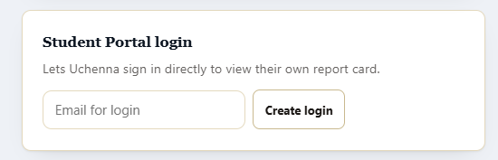
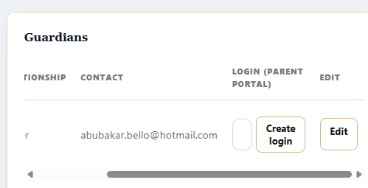
- Why do we have to manually create login for students and parents. As we said earlier, students can login with their admission number and the default password which must be change upon first login. Parents can login with either email or phone number

- Staff and parent list does not have the sort and filter option

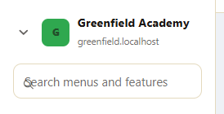
- THE SEARCH BAR STILL HAS THE ICON, TEXT BLINKER AND TEXT OVERLAPPING OVER THEMSELVES

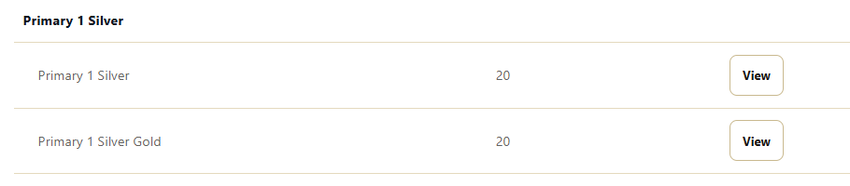
- I renamed the first class stream to Primary 1 silver and the main class name added silver to it and the second stream also added silver to it. Each stream should be a unique class under the main class name

- Under timetable, there should be a subsection for examination timetable that the school admin will populate either by entering it in the provided fields (Paper 1, Paper 2, Break, Paper 3… as the admin want it, the duration per paper and break, when the first paper starts and the time auto populates for other ones) – or the admin can upload a template (system should provide a template to be filled and uploaded them populated) – this is done by selecting which section of the school is meant for as set under classes, it can also be specific to just a class and not only a section)

Sample below


- 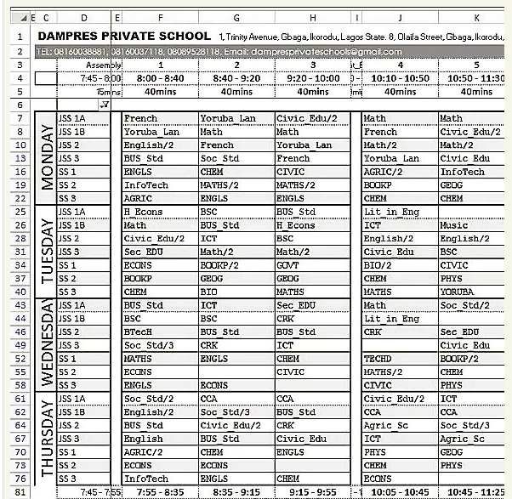there should be a timetable like this showing for all classes in the school so that the admin, school owner, head teacher, assistant, priipal and vice principals can see it at a glane

- Here is how a class timetable should look like
 | 1ST PERIOD | 2ND PERIOD | SHORT BREAK | 3RD PERIOD
MONDAY | MATHEMATICS  MRS SUNDAY | LITERACY  MR SEGUN | SHORT BREAK | ICT  MISS OBI
TUESDAY |  |  | SHORT BREAK
WEDNESDAY |  |  | SHORT BREAK
THURSDAY |  |  | SHORT BREAK
FRIDAY |  |  | SHORT BREAK

THEN POPULATE THE TIMETABLES FOR CLASSES AND EXAM FOR ALL CLASSES IN Greenfield Academy. MAKE USE OF THE SUBJECTS THERE AND THE STAFF FOR EACH TEACHERS
DEFAULT DURATION PER PERIOD AND BREAK ARE SEEN BELOW, THE ADMIN CAN CHANGE IT
 | FIRST PERIOD START | PERIOD | SHORT BREAK | LONG BREAK
NURSERY | 8:30AM | 25 MINUTES | 15 MINUTES | 30 MINUTES
PRIMARY | 8:15AM | 30 MINUTES | 15 MINUTES | 30 MINUTES
SECONDARY | 8:00AM | 40 MINUTES | 15 MINUTES | 30 MINUTES

7/22/2026 FEEDBACKS
- 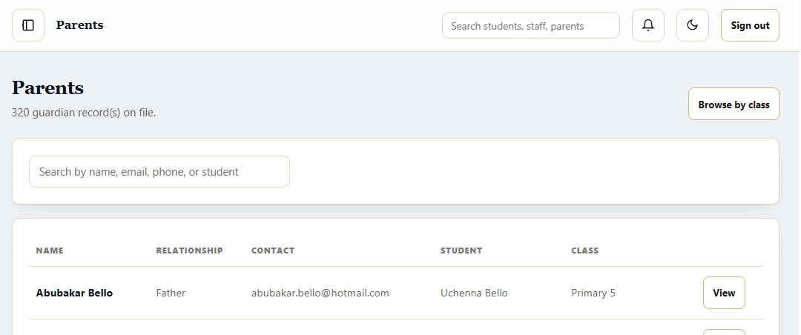THE PARENTS AND STAFF FULL LIST HAS MISSING SORT AND FILTER OPTION
- 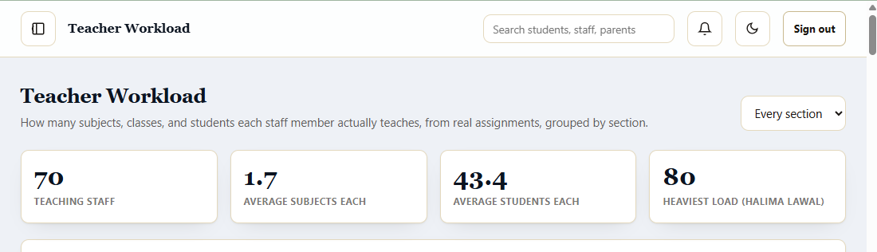LET’S ADD A CARD ALSO SHOWING TEACHER(S) WITH LOWEST LOAD – ALSO I NOTICED THAT ITS NOT ONLY ONE TEACHER THAT HAS SAME NUMBER OF LOAD AS CAPTURE SO LET’S BE ABLE TO CLICK ON EACH HEAVY AND LIGHT LOAD CARD TO list of those in it as a pop up
- 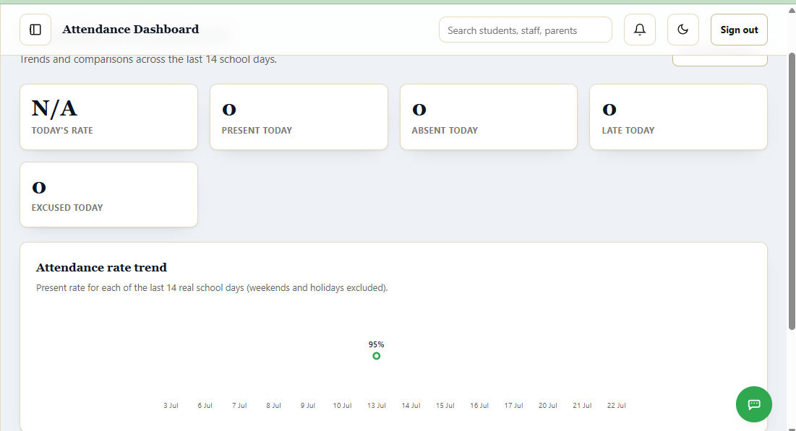a. one should be able to swith between staff attendance and student attendace here
B,. the data here are incomplete, one should have a date/calendar at the top which allows one to go to a date and see the data there which should only allows previous dates only
c. Also, I want you to populate attendance data for staff and learners for the past one year
- 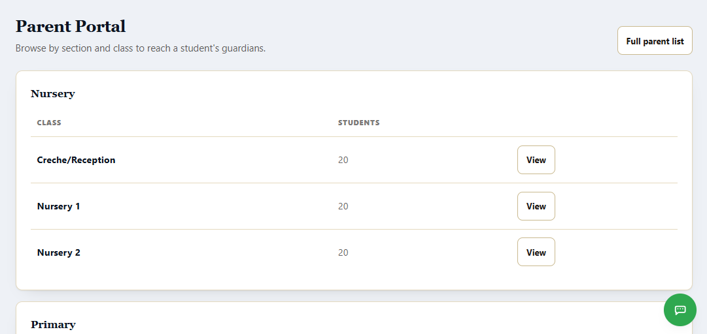let’s add a collapsible way for each section under staff and parent portal list view here
- 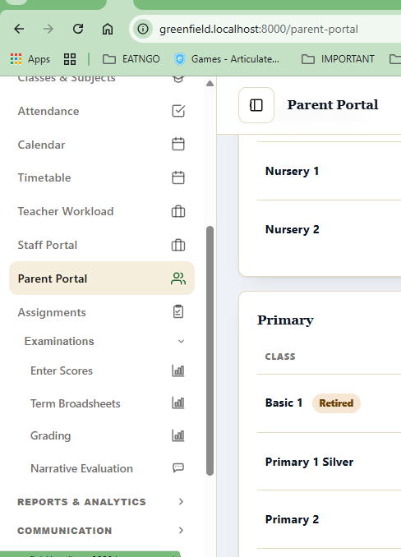when I click to access a menu option, when the menu opens, the current menu tab should not go to the bottom of the menu section but should be at the top of central as scroll to in the image above
- 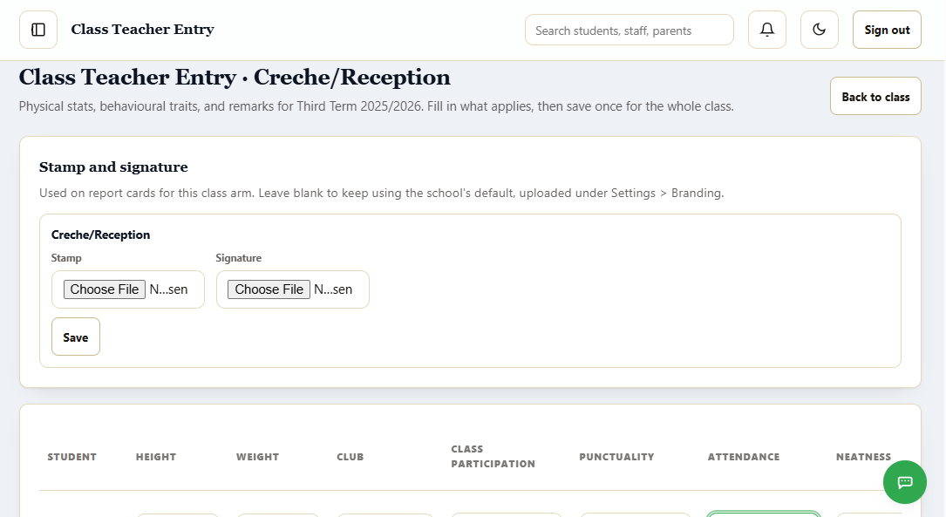template download and upload is missing here for Narrative Evaluation classes. One should be able to download the template with all learners details and fill necessary areas

7/22/2026 part 2
- Make the Master Timetable exportable as csv or pdf
- Examination timetable should also appear like the
- 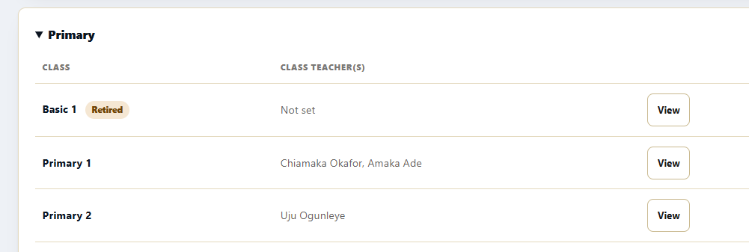the class stream should be separated here under staff portal and parent portal too and same under the report card page too
- 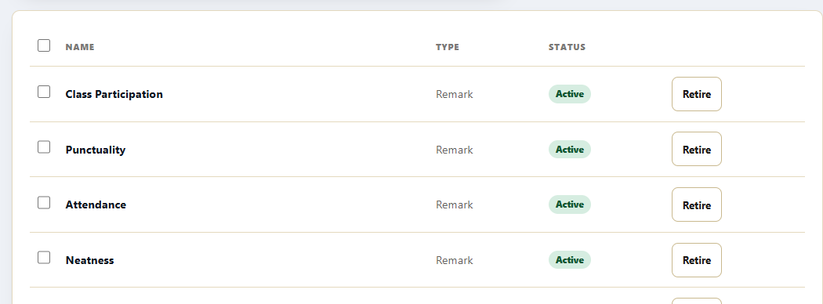one should be able to edit current behavioural/psychomotor traits that appears for each child reports
- 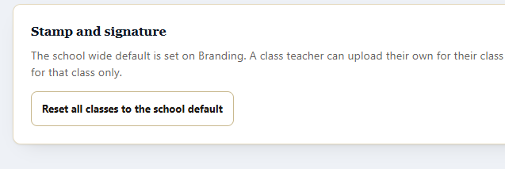option to also upload the school wide stamp and signature should appear here too (http://greenfield.localhost:8000/report-cards/settings)
- 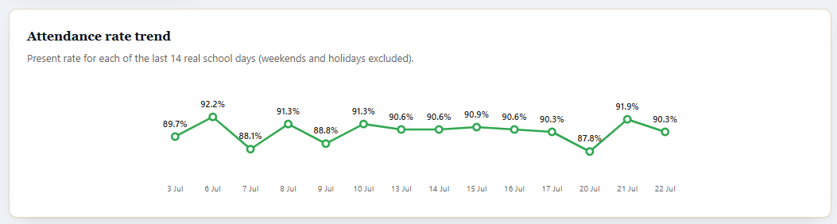let’s have alterative style ot charts to select for this current ones – apply to all areas that the chart is
- Add pagination to “Performance at risk” if data there is more than 10. So we should have 10 per page
- http://greenfield.localhost:8000/students/import should not be a menu option under reports and analytics since it can be found under the student portal. Note, you are only removing it from the menu side, page content and function still remains
- 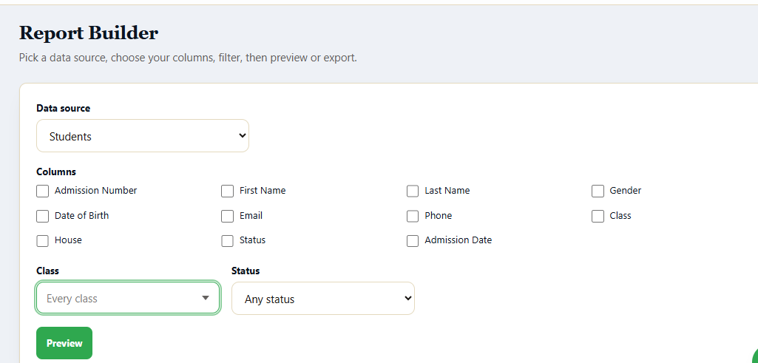report builder should have much more items to combine into a report. Check others things like, attendance, performance, behavioural, etc
- Academic Insights page should have the filter and sort option to the data there
- 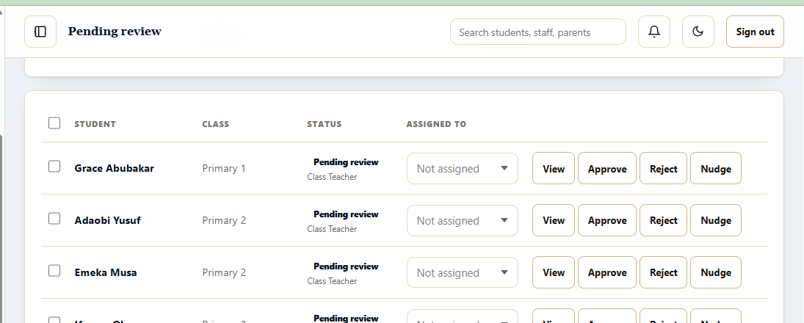under pending review section/page, let’s also add the filter and sort option there too
- 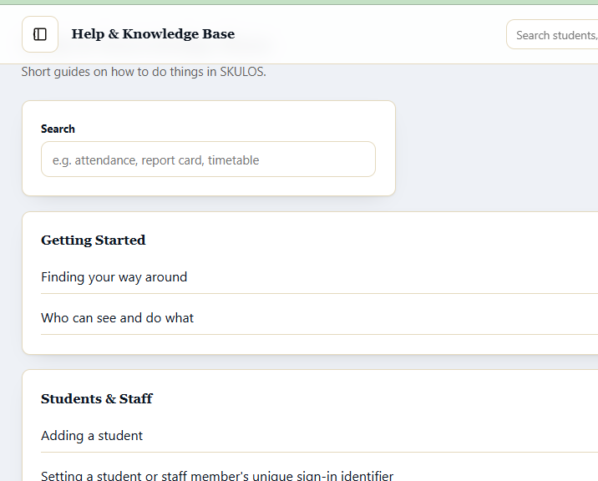let’s make this section much more presentable and great. Also lets add more help or knowledge to it
- 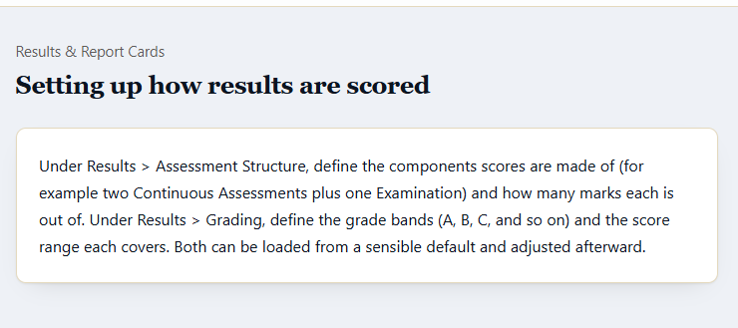this should be presented more as a procedure or step. Do same for all lke this. Also for everyone, add a button that takes them to where to start the process or knowledge under help
- Under School Profile, one should also be able to upload the school logo there. Also one should be able to add addition details there if needed
- 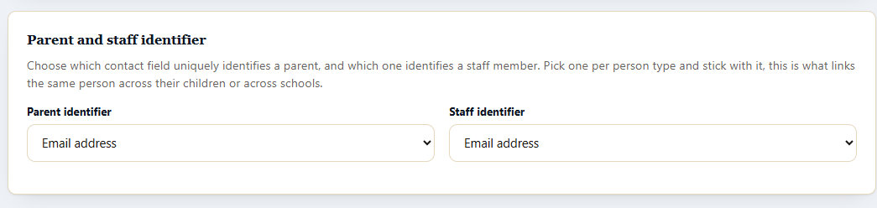I want the option of having both as the unique identifier too– both email and phone number
- staff and parent field setting keeps going back to student field settings. I
- Landing Pages should also have bulk way of getting it done for all users instead of doing it one after the other. So add the bulk approach too
- 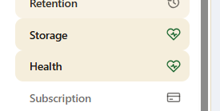storage and health should be merge as one menu since its same data there

